Crime Scene Report

Section 1. First Responder Report
Officer Name: | Time of Arrival: | Date of Arrival:
Victim Name: | Victim Address:
First Responder Report:

I met with Frank Gaines, the homeowner who had reported the burglary. Gaines told me he lives alone. He was out of town on business when the burglary happened. He had left on Monday, April 5, at approximately 6:15 p.m. and returned on Friday morning at approximately 8:45 a.m. Because he used his car for the trip, there was no car in his carport when he was gone. He said because he left during daylight, he hadn’t thought to leave any lights on. He is a sales representative for Pfizer, and many people know that he often does business from home and makes sales trips.

When he returned from his trip, he saw a broken window over the kitchen table. The following items are missing from his kitchen, which also serves as his home office:

- Dell Alienware computer Serial #1534920814
- HP Laserjet Printer Serial #23179085
- Brother IntelliFax-41003 machine Serial #5656778912

Section 2. Crime Scene Documentation
Detective Name: |  |  | Time of Arrival: | Date of Arrival:
Crime Scene Observations:

I searched Gaines’ kitchen by dividing it into four zones as shown in the diagram below. I began my search in Zone A where I lifted 2 fingerprints from the door handle at location 1. In Zone B, I collected 3 fingerprints from location 2 and 1 hair sample from location 3 on the kitchen island. I also collected 2 fingerprints from the refrigerator handle at location 4. In Zone C, I collected a tissue with a red stain at location 5 and a fiber at location 6. In Zone D, I saw fragments of glass on the floor at location 7 and collected a red liquid from the edges of the glass.

Labeled Diagram of Crime Scene: (include numbers and letters for each piece of evidence collected)

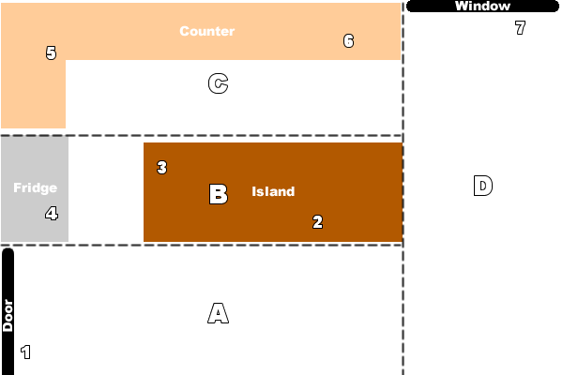

Section 3. Evidence (Insert photographs along with location identifiers.)
Location: | Location: | Location:
Location: | Location: | Location:
Location: | Location: | Location:
Location: | Location: | Location:
Location: | Location: | Location:
Location: | Location: | Location:

Section 4. Witness Interviews
Witness Interview 1:

I questioned the neighbor (Anna Morgan, age 44). She told me:
- Her dog started barking at about 2 a.m. Wednesday, April 7.
- She had a headache and did not feel like looking outside.
- She put the dog into her guest bedroom so that she could get some sleep.
- Nothing else unusual happened while Gaines was away.

Witness Interview 2:

Witness Interview 3:

Witness Interview 4:

Section 5. Suspect Interviews
Suspect Interview 1:

Suspect Interview 2:

Suspect Interview 3:

Suspect Interview 4:

