Trends in Crime
Analyze your chosen graph, complete research to get a more complete picture of the potential crime trend, and deliver a final verdict about the trend your graph indicates.

Graph
Insert a picture of your chosen graph below.
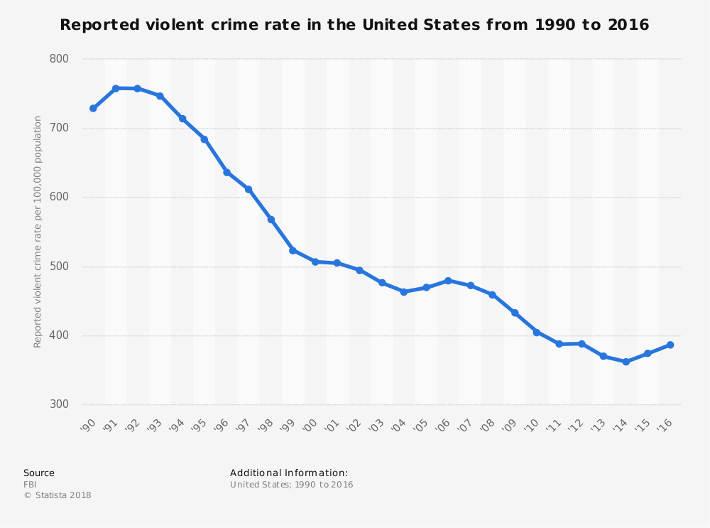

What crime trend does the graph indicate?
This graph indicates that violent crime has steadily decreased in the United States since the beginning of the 1990s.

Identify and describe any misleading techniques used to display the data.
The graph cuts off the y-axis by starting at 300 instead of zero. This makes the amount of decline seem greater than it actually is. Also, since the y-axis uses labels in the hundreds (300, 400, 500, etc.) it may embellish the amount of violent crime that is being reported since those numbers represent the reported violent crimes per 100,000 people. A more representative measure would use decimals to reflect the unit rates of reported crimes. In this case, a number like 700 in the graph above would be represented by a unit rate of 0.007.

Research
Insert two additional graphs that relate to this crime trend. Try to find graphs that are from credible sources, and see if you can find data from a broader range of years than the original graph to get the whole picture.
Graph 1:  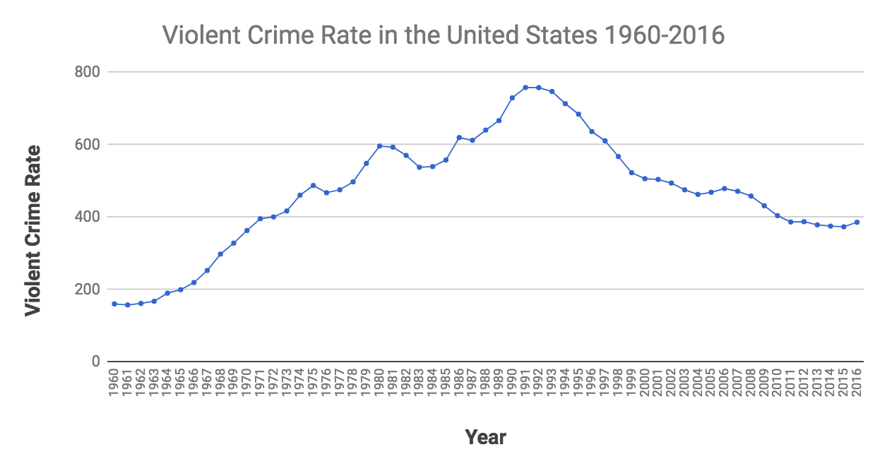 | Graph 2:  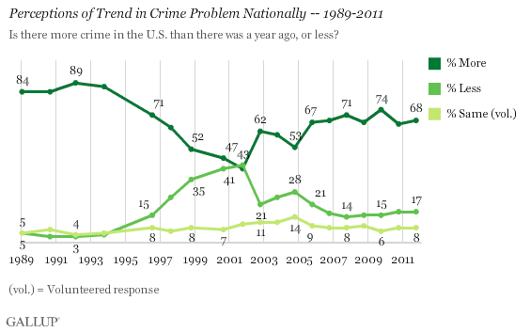
Source:  https://www.politifact.com/truth-o-meter/statements/2017/dec/04/jeff-sessions/violent-crime-some-still-well-historical-highs/ | Source:  https://news.gallup.com/poll/150464/americans-believe-crime-worsening.aspx
How do these graphs compare to your original graph? Do they support the trend or put the trend into question? Explain.

These graphs support the original graph, but also provide a broader view of the crime rate trends in America. The first graph shows that, indeed, the violent crime rate has been dropping in America since the 1990s; however, it also shows that the violent crime rate is double the rate from 1960. The second graph shows how people’s perceptions of the crime rate differ from the actual crime rate. Since 1990, a majority of people believe that there is more crime occurring than in previous years despite the fact that this is not the case.

What are the causes for this crime trend? Write an essential question that gets to the heart of the issue. Then, find two separate sources that explain why this crime trend is or is not valid. Answer the question using each source.

Essential Question:
Why has the violent crime rate decreased in America since the beginning of the 1990s?
Answer 1:  Wikipedia cites several possible reasons why crime has steadily decreased since the 1990s:  - An increase in police officers and advancement of training and techniques for police officers.  - Mass incarceration (more criminals are in jail now than before).  - Crack-cocaine, which can be linked to violent crimes, became popular in the 1980s, but use of the drug decreased in the 1990s.  - Legalized abortion reduced the number of children born into “difficult circumstances”.  - The lead-crime hypothesis states that exposure to lead could lead to violent crimes. Lead exposure has been greatly reduced since the 1980s, which could explain the reduction in violent crimes.  - Some studies have shown that increased immigration led to decreased crime rates throughout the 1990s. | Answer 2:  An article in the Atlantic questions several theories for the “Great American Crime Decline”:  - Although unemployment was low in the 1990s, studies have shown that unemployment plays a small part in causing crimes.  - Although rates of alcohol usage increased in the 90s, Canada and Europe have higher rates of alcohol consumption, but lower crime rates.  - Mass incarceration may have a “modest” effect on crime rates, but studies have suggested that harsh prison conditions and long sentences may make inmates more likely to commit crimes again once released.  - Legalizing abortion could have impacted crime rates, but hundreds of thousands of illegal abortions were already occurring before abortion became illegal in the US.  - The correlation between lead and crime rates significantly decrease if another data set is used (Bureau of Justice Statistics as opposed to FBI statistics).
Source:  https://en.wikipedia.org/wiki/Crime_in_the_United_States | Source:  https://www.theatlantic.com/politics/archive/2016/04/what-caused-the-crime-decline/477408/

Verdict
Based upon your research, does your crime trend have strong support or questionable support?
Strong Support

Fully explain your reasoning for your final verdict.
There is strong support to indicate that violent crime has decreased significantly in the United States since the beginning of the 1990s. Both FBI and Bureau of Justice statistics support this conclusion; however, identifying the underlying causes of this reduction in violent crimes is more difficult to determine. While police force improvements, mass incarceration, legalized abortion, and lead-crime correlations are popular theories, each theory has its flaws.

